**How To Register As Developer On Play Store**

* Go to developer.android.com.
* On the top of the Homepage, you will see *Design*, *Develop* and *Distribute* options.

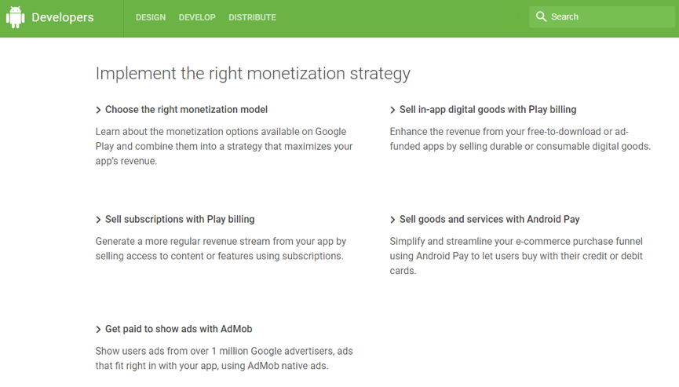

* For registration, click on the *Distribute* option.
* You will enter the Google Play Console page, click on the Sign in button. A page will be displayed where you need to perform ***four steps*** for complete registration:

1. **Sign in with your Google account-** Firstly, you have to Sign in with your *pre existing Google/Gmail account* if you have the one or else you need to create a New ID. You can also *Sign in with a different account*.

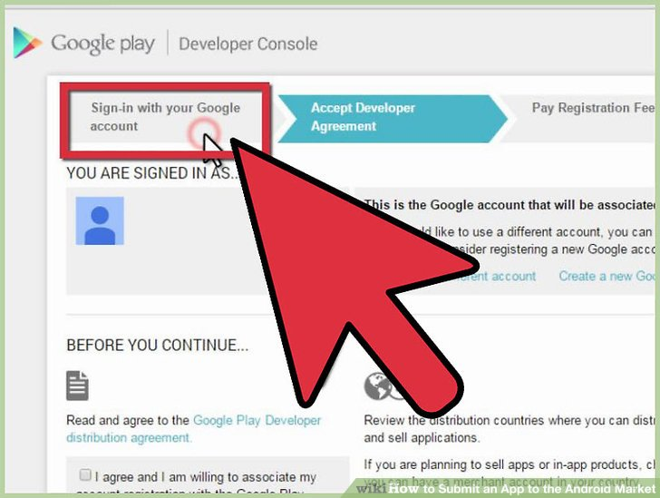

1. **Accept the Developer Agreement-** Once you have Signed in, the next step is to Accept the Google Play Developer Distribution Agreement by Clicking on the *Check Box* present under Accept developer agreement option on the page.

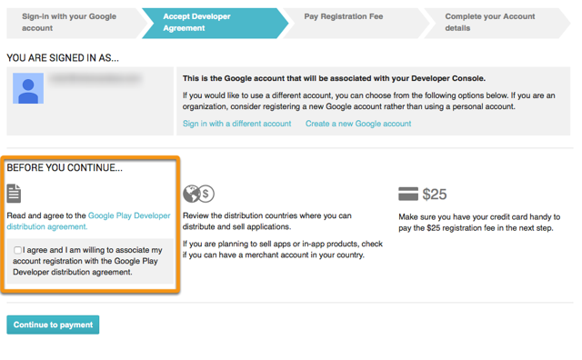

1. **Pay Registration Fee-** For making money and publishing your apps, you need to pay *$25* as a registration fee. For paying the fee, click on the Continue To Payment option at the bottom of the page.

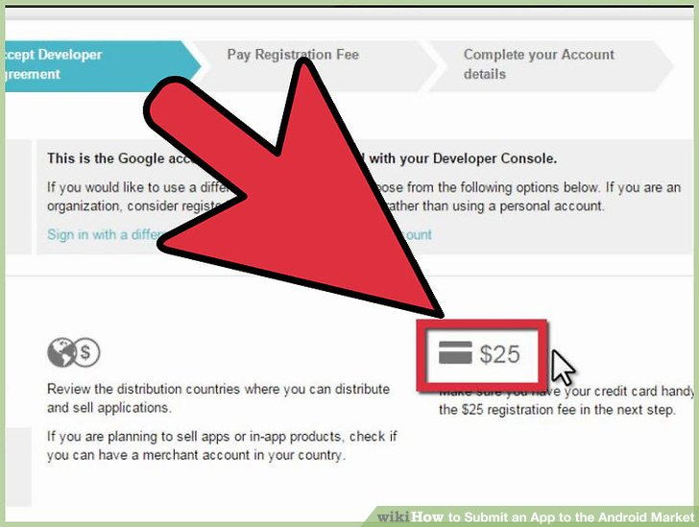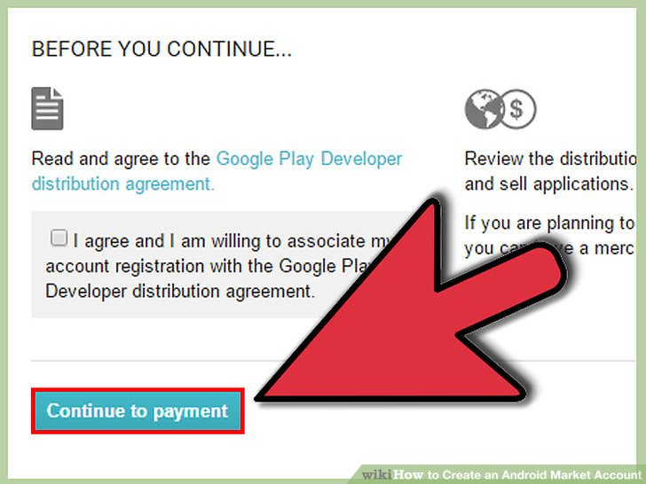

A payment page will appear where you need to enter the payment information to set up a *Google*

*Payments Account*. Then click on Accept and continue button.

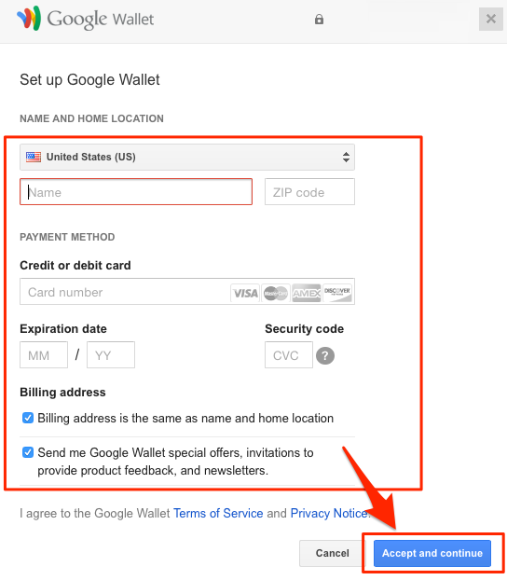

1. 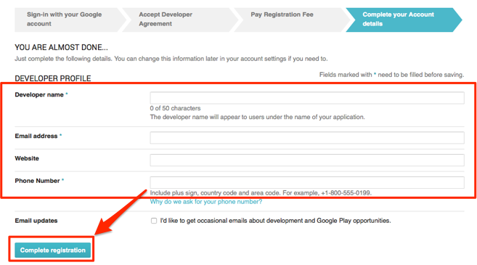**Complete Your Account Details-** On the last page, you have to fill up some information about developers name, email address, website and phone number. After that click on the button Complete Registration.